WHAT WE SAY AND WHAT WE DO IN THE CLASSROOM

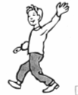 | 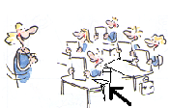 | 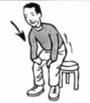 | 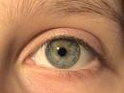
Hello! | Who’s absent today? | Sit down ! | Look !
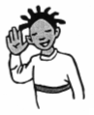 | 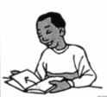 | 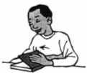 | 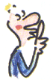
Listen !! | Open your book | Close your book! | Be quiet!
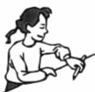 | 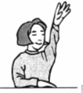 | 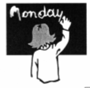 | 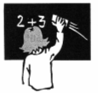
Take your pen! | Put up your hand! | Write the date! | Clean the blackboard!
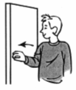 | 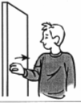 | 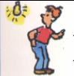 | 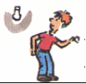
Close the door | Open the door | Switch on the light | Switch off the light
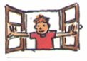 | 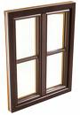 | 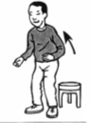 | 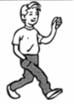
Open the window | Close the window | Stand up ! | Bye!

Don’t forget! Be polite and say:

PLEASE AND THANK YOU

